



Pelvic Exercise Programme

Introduction
We are beginning to understand the role of the musculoskeletal system in endometriosis pain. By optimising your muscle balance, joint mobility, fitness and posture it seems we can improve people’s experience of pain, which is also true in other pain conditions. Included in this leaflet are some basic exercises designed to improve your pelvic health.
Advice for exercising:
- It is really important to ensure whenever you are staring a new exercise to begin with very small amounts and gradually build things up if and when your body feels able to.
- Work within your body’s limits (which may change from day to day) and try to not push your body into discomfort or pain.
- During stretch exercises you would expect to feel a stretch sensation, but again not pushing into discomfort.
- Allow a recovery day between each session to check your body coped okay and you haven’t flared.
- Ensure you seek advice if you feel unsure of any particular exercise
The exercises included help to rebalance some of the muscles we know become dysfunctional in some patients with endometriosis.

Stretching Exercises
Commonly muscles can become tight and painful because of both posture, which may be in response to pain generated from endometriosis, and overuse, as other muscles become weakened requiring these muscles to compensate.
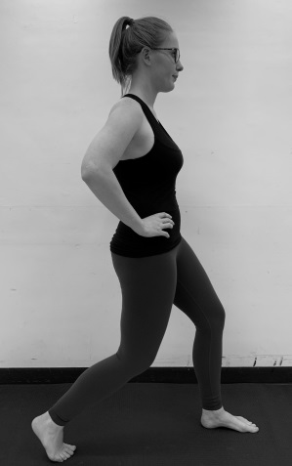 | Hip flexor stretch in standing  Stand with one leg in front of the other. Raise your heel of the back leg and soften your knees. Tuck your bottom under so that your pelvis tilts under.  You should feel a stretch at the front of your hip/ groin.  Aim to hold for 30 seconds each side

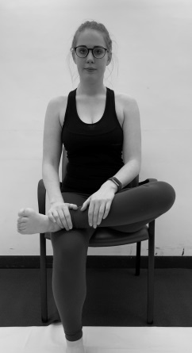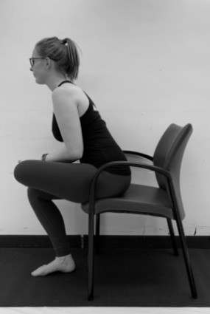  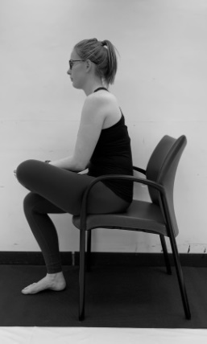 | Piriformis stretch in sitting  Cross one leg over the other as shown. Gently push your knee towards the floor. If comfortable, lean forward with your back straight. If the stretch feels too intense, slouch back slightly into the chair  Aim to hold for 30 seconds each side

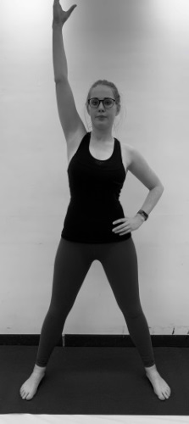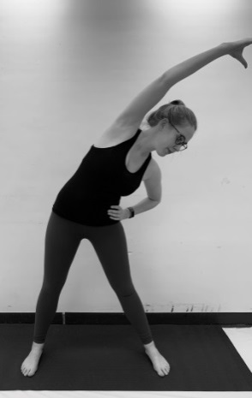 | Quadratus lumborum stretch  In standing, raise up one arm up above your head. Bend to the opposite side, until you feel a stretch on your side. Then twist your spine slightly towards the floor keeping your pelvis forward.  Aim to hold for 30 seconds each side

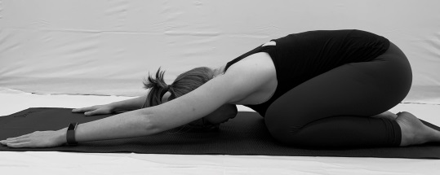 | Childs pose  Bring yourself from seated kneeling into the forward position as shown. You may feel a stretch into your back, shoulders and hips.  You can also gently walk arms over to each side, holding for a short period of time to increase the stretch into your shoulders.

Mobility Exercises
Spinal mobility helps to optimise the function of muscles surrounding our pelvis and relieve symptoms of lower back pain.
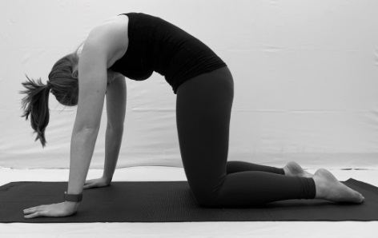  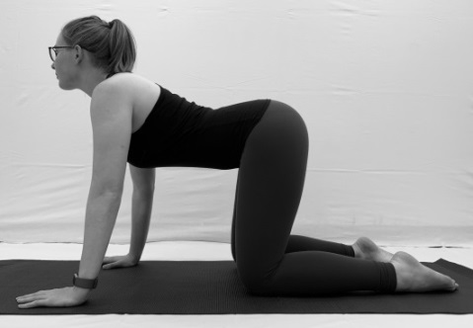 | Cat and cow stretch on all fours  On all fours with your knees and ankle hip width apart, curve back up towards the ceiling, tucking your bottom under and looking towards your tummy. Then arch back your spine down, looking forward and tilting your pelvis up to the ceiling. Aim to work fluidly between the two within comfort.

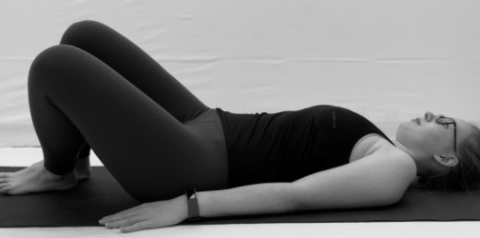 | Hip Twist  Lying on your back with your knees together and bent. Slowly relax your knees down towards the floor, keeping your knees together and your shoulders on the ground. Repeat the other way.

Control Exercises
It is important to gain control in our core muscles for our muscles to be strong. The transverse abdominis muscle is a deep layer of muscle that acts as the body’s natural corset, supporting the back and pelvis. It is common that people who experience chronic pelvic pain are weak in this muscle and therefore over compensate by using their oblique or rectus muscles.
The pelvic floor is also a core muscle. Commonly people who experience pelvic pain have pelvic floor muscles which are overworked, shortened and painful. Diaphragmatic breathing can help to improve the pelvic floor muscles ability to work through range and gives people a sense of what these muscles feel like when they are more relaxed. This will help with reducing pain and increasing strength and control.
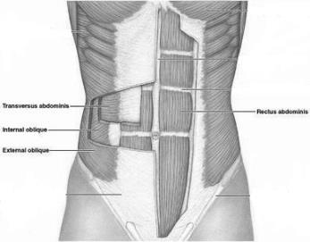  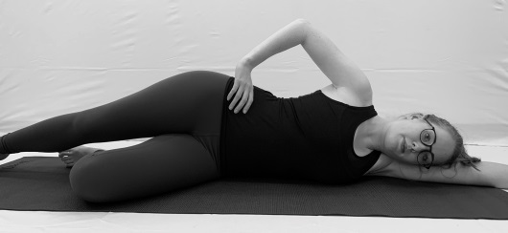 | Transverse Abdominis Activation:  Lie on your back or on your side or in sitting. Place your hands just slighly in from you hip bones so they are resting over your lower tummy. Completely relax your abdomen.  Gently draw your lower abdomen away from your waistband (approx. 20% of your full squeeze). You should feel a gentle tension underneath your hands. You should see minimal movment of the abdomen and your upper abdominal muscles and back should remain still.  Keep breathing and try to maintain the hold. If you feel it relax, don’t fight it, fully relax and start again. If you feel your upper abdominals, pelvic floor or other muscles kicking in, fully relax and reset.  Start by completing for a few seconds and then build up the time, ensuring your body isn’t cheating.

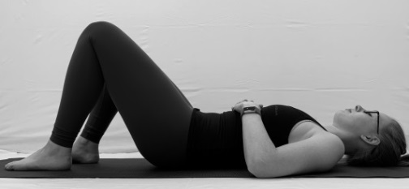 | Diaphragmatic Breathing:  Lying on your back with your knees bent, place one hand over your lower abdomen and one over your chest.  Start with 2-3 slow, deep abdominal breaths (breathing in through your nose and out through your mouth) so that your tummy passively “swells” out. You should not feel as though you are “pushing” your tummy out. Try to keep your chest still. Then go back to breathing normally.  Now, gently tighten around your back passage as if stopping wind and immediately relax. Try to let these muscles relax as far as possible. Return to deep abdominal breathing for 2-3 repetitions. Notice the subtle further dropping away of the muscles.  Continue the cycle up to 10 times.

Strengthening Exercises
Muscles can become weakened in response to posture, pain and inactivity. Strengthening the pelvic muscles helps to rebalance control, reducing the body’s need to compensate using the muscles identified above.
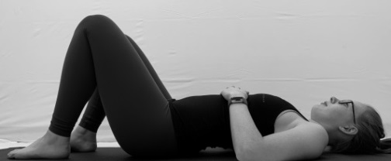 | Pelvic tilts in lying  Lying on your back in your neutral position; engage your deep abdominal and bottom muscles.  Slowly curl your pelvis backwards and lift slightly. Then curl back down gently.

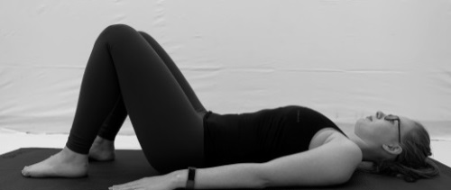  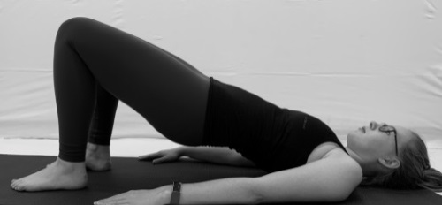 | Shoulder bridge  Lying on your back in your neutral position; engage your deep abdominal muscles.  Squeeze your bottom muscles and start to raise your hips off the ground slowly and segmentally so that your tailbone is the first to lift. The movement should be as controlled as possible. Make sure that your ribs are always lower than your hips.  As you come back down to the floor, you should ensure the movement is segmental and controlled so that your tailbone is the last part to touch the floor.

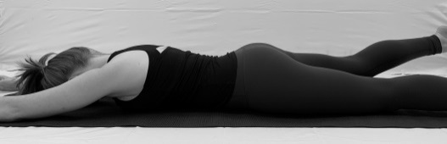 | Swimming  Lying on your tummy in your neutral position (remember you need to tuck your bottom under); engage your deep abdominal muscles.  Keeping length in your spine, lift one leg off the floor, feeling a squeeze in your bottom muscles. Alternate legs.  Keep your arms relaxed and place a pillow under your tummy if required.

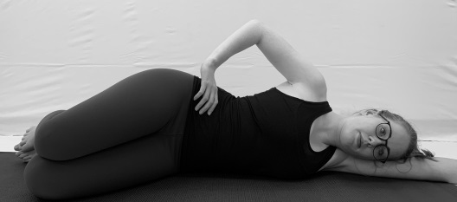  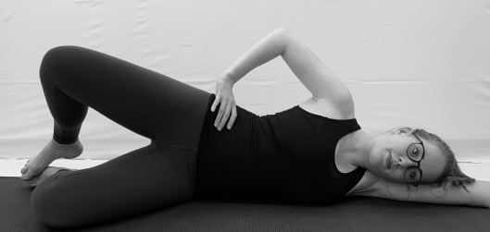 | Clam  Lying on your side in your neutral position with your legs bent and feet in-line with your bottom; engage your deep abdominal muscles.  Lift your top leg up, keeping your hip bones facing forwards to avoid rocking backwards. Slowly lower your leg back to its starting position. Complete as many repetitions on one side as possible (taking into consideration pacing) before completing on the other side.

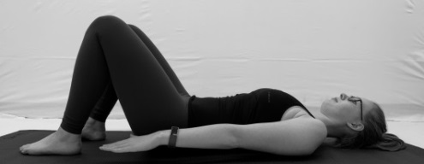 | Hundreds  Lying on your back in your neutral position; engage your deep abdominal muscles.  Raise your arms slightly off the floor and pulse the arms gently from the shoulders.  Aim for 100, however, you will need to build up to this.

