Laparoscopy for Pelvic Pain: Understanding the experiences & perspectives of women and healthcare professionals (LaPPCare1)

PARTICIPANT INFORMATION SHEET (Healthcare professionals)
Central University Research Ethics Committee Reference: [MS IDREC 1129637]

We would like to invite you to take part in our research study. Before you decide, it is important that you understand why the research is being done and what it will involve. Please take time to read the following information and carefully consider if you would like to take part. Contact the team (see details above) if it would be helpful to have an informal conversation before you decide or have any questions. Please do discuss it with others if you wish.
In this study, we use the term ‘women’ to refer to biological females who may access care through gynaecology services. This study will be accessible to all who meet the inclusion criteria no matter how they identify.

Why is this research being conducted?
Chronic pelvic pain (pain that lasts for more than 3 months) is common and impacts on many areas of life. For women with chronic pelvic pain, it is not possible to tell from symptoms alone who has an underlying disease such as endometriosis, and who doesn’t. Many women have keyhole surgery to investigate symptoms and around half will have normal findings. Understandably, many people feel confused when investigations are normal but symptoms persist. We know that, in this situation, women are often unhappy with the healthcare they receive, that they feel dismissed, unsupported and confused about how to manage their symptoms. HCP have told us that they also find these conversations difficult and that women have unmet support needs.

The purpose of this study is to find out more about the experience of having normal findings (nothing identified to explain pain, such as endometriosis) following keyhole surgery to investigate symptoms of pelvic pain and understand what support and information it would be helpful to have around the time of surgery. We will use this information to help plan changes to improve experiences of healthcare. The University of Oxford is working with two national charities, Cysters and the Pelvic Pain Support Network, on this project.

Why can take part?
We want to hear from fully qualified healthcare professionals working in the NHS about their experience of providing care to, and views on support needs for, adults who have ongoing pelvic pain, have had keyhole surgery (gynaecological laparoscopy) to investigate symptoms of chronic pelvic pain in the NHS more than 6 months ago and within the last 5 years, and had normal findings at surgery.
You will be eligible to participate if you meet the above criteria. We want to speak with 8 healthcare professionals from different professional and personal backgrounds and who are involved in different aspects of the care pathway to take part. This will help to ensure we hear from a range of people with different experiences and perspectives. In this exploratory project, we might not be able to invite everyone who expressed an interest in the project to take part, but we will let you know whether we will invite you to interview.

Do I have to take part?
No. It is up to you. If you do decide to take part, please complete the expression of interest form using the QR code at the end of this information sheet. Alternatively, you can call or email us; our contact details are provided at the end of this information sheet. You are free to stop taking part at any time during the research without giving a reason. If you decide not to take part, you do not need to do anything.

What will happen to me if I take part in the research?
We will arrange a time to meet with you to talk about your experience of working as a healthcare professional and providing care to women with chronic pelvic pain who have undergone diagnostic laparoscopy. This meeting can be virtual (over MS Teams) or over the telephone. The meeting will be arranged at a time that is convenient for you and will last between 30-60 minutes, depending how much time you have available and what you want to discuss.
At the start of the interview, we will explain the study and answer any questions you have before you decide whether you would like to take part, and ask for your consent to proceed with the interview. We would like to audio record the interview (recording what is said) so we have an accurate record of our conversation. If you do not want us to record the interview, we will instead make some notes as we go along to help us remember what you said.
We will ask you to tell us about your experience of providing health care to women with CPP around the time of laparoscopy, and what it’s like to deliver or discuss (‘normal’) surgery findings. We will also ask what support you think would be helpful for this patient group and if you have any ideas about how healthcare could be improved. You are free to take a break or stop the interview at any time and do not need to give a reason for this.
At the end of the interview, we will ask if you are willing to share information about your professional role. We will use this information to describe who took part in the study and to give context to the data. It will help us understand different aspects of the care pathway. You can decide if you are willing for this information to be reported.

What are the possible disadvantages and risks in taking part?
Taking part will involve giving up some of your time. If you tell us about care which compromises patient safety or dignity, we may need to escalate concerns through appropriate NHS procedures or to professional regulatory bodies.

Are there any benefits in taking part?
There will be no direct or personal benefit to you from taking part in this research. It is hoped that this research in combination with other linked projects will lead to better care for women who undergo diagnostic laparoscopy to investigate symptoms of chronic pelvic pain. You will be offered a £25 voucher in thanks for your time.

How will my data be used?

The information you provide in the expression of interest form will be used to help ensure we talk to healthcare professionals from different backgrounds. We will use this information so we can get in touch with you to invite you for an interview and send the shopping voucher to thank you for your times. We will also use the contact details provided on the expression of interest form to share publications about the study, if you opt to receive these.

The information you share with us in your interview will help us better understand the support needs of women undergoing a laparoscopy and gather perspectives how to improve healthcare. We will combine the information from all the interviews with patients and healthcare professionals to:
- Develop a questionnaire survey to ask more women about their experience of laparoscopy.
- Make a short film (where words are voices by actors) which describes the experiences of women who have had keyhole surgery and the changes they would like to see in how care is provided.

What will happen with to my data?
All datawill be collected and stored in accordance with the University of Oxford data management policy.
The information you provide in the Expression of Interest form will be stored on University of Oxford secure servers. Contact details will be deleted from this document after the final interview has been complete. The information on the Expression of Interest form will not be linked to the information you share with us in your interview.
You Contact Details (provided in the Expression of Interest form) will be stored securely on University of Oxford secure servers. We will delete these after the final interview has been completed and we have sent out vouchers for interview participation. If you want us to send you publications about the research, we will keep your contact details until all publications are completed.
The researcher will go through the Consent Form with you at the start of the interview and, with your consent, they will complete this form on paper on your behalf. The paper copy will be stored in a locked filing cabinet in the Nuffield Department of Women’s and Reproductive Health, University of Oxford. An electronic copy will be made and stored on the University of Oxford secure servers. Both the electronic and paper copies will be permanently deleted 5 years after the study has ended. If you would like a copy, we will send one to you either by email or post (you can choose how you want us to send it to you).
We will store the audio recording from your interview on the University of Oxford secure servers. We will transcribe (make a written copy) of the audio recording and, once this has been checked it’s accurate, we will delete the recording of your voice. Interview transcripts and notes from interviews will be stored electronically on the University of Oxford secure servers for the five-year retention period from the end of the study.
At the end of the interview (once the audio recording has been switched off) we will ask if you are willing to share demographic information (for example, your age group, ethnicity and gender identify). This information won’t be linked to your individual interview or consent form: it will be used to describe the whole sample, not individuals. This information will be stored electronically on the University of Oxford secure servers for the five-year retention period from the end of the study.
To protect your identity, we will use a document to link your consent form with the other documents from your interview, which will have an identification number (and not your name) on them. This document will be password protected and stored on University of Oxford secure servers. We will also store a paper copy in a locked filing cabinet in the Nuffield Department of Women’s and Reproductive health, University of Oxford. Both the electronic and paper copies will be permanently deleted 5 years after the study has ended.
This study is the first in a series of studies looking at how we can improve care around the time of laparoscopy. We will use the information gained from this study to inform future linked projects.
The information you provide will be accessed by the research team (whose names are listed at the bottom of this sheet). Responsible members of the University of Oxford may be given access to data for monitoring and/or audit of the study to ensure that the research is complying with applicable regulations.
You can find out more about how we will use your data by contacting emma.evans@wrh.ox.ac.uk

Will the research be published and could I be identified from any publications or other research outputs?
The findings from the research will be written up to share what we have learned with other researchers and healthcare providers. We will also prepare a summary of what we have learned for everyone who has taken part in the study: this will be emailed to you or sent via the post (depending on the contact details you provide us with).
We would like your permission to use direct quotations in any research outputs, including journal articles and conferences, but this is optional and would not identify you. We also plan to make a video (called a ‘trigger film’) in which some of these quotes are voiced by actors. This film will be shown in workshops in which patients and healthcare professionals will work together to plan improvements to healthcare. The film will ensure patients’ experiences are kept in mind when planning healthcare. We may also use this video at conferences or research meetings to help share our research findings and methods. You will be invited to view and comment on the film before it is shared with others.

Data Protection
The University of Oxford is the data controller with respect to your personal data, and as such will determine how your personal data is used in the research. The University will process your personal data for the purpose of the research outlined above. Research is a task that is performed in the public interest. Further information about your rights with respect to your personal data is available from the University’s Information Compliance website at https://compliance.admin.ox.ac.uk/individual-rights.

Who is funding the research?
This study is being led by Prof Katy Vincent, Nuffield Department of Women’s and Reproductive Health. University of Oxford. Other University of Oxford Researchers are also involved in this study and we are working in partnership with Cysters (https://cysters.org/) and the Pelvic Pain Support Network (https://www.pelvicpain.org.uk/). It is funded by in part by the NIHR Oxford Biomedical Research Centre (BRC) which is a partnership between Oxford University Hospitals (OUH) NHS Foundation Trust and the University of Oxford.

Who has reviewed this research?
This research has received favourable opinion from a subcommittee of the University of Oxford Central University Research Ethics Committee. (Ethics reference: MS IDREC 1129637).

Who do I contact if I have a concern about the research or I wish to complain?
If you have a concern about any aspect of this research, please contact Prof Katy Vincent on katy.vincent@wrh.ox.ac.uk and we will do our best to answer your query. We will acknowledge your concern within 10 working days and give you an indication of how it will be dealt with. If you remain unhappy or wish to make a formal complaint, please contact the University of Oxford Research Governance Ethics and Assurances (RGEA) office on 01865 (6)16480, or the director of RGEA, email rgea.complaints@admin.ox.ac.uk.

Further Information and Contact Details
If you would like to discuss the research with someone beforehand (or if you have questions afterwards), please contact the lead for this study: Professor Vincent, Consultant Gynaecologist.
Email address: katy.vincent@wrh.ox.ac.uk,
Telephone number: 01865 221004
Nuffield Department of Women’s and Reproductive Health
University of Oxford

Research Team
From the University of Oxford: Prof. Katy Vincent, Dr Emma Evans, Prof. Christian Becker, Dr Abigail McNiven & Dr Sharon Dixon
Partners: Neelam Heera, Cysters, & Judy Birch, the Pelvic Pain Support Network

To register your interest in taking part, please follow the link below
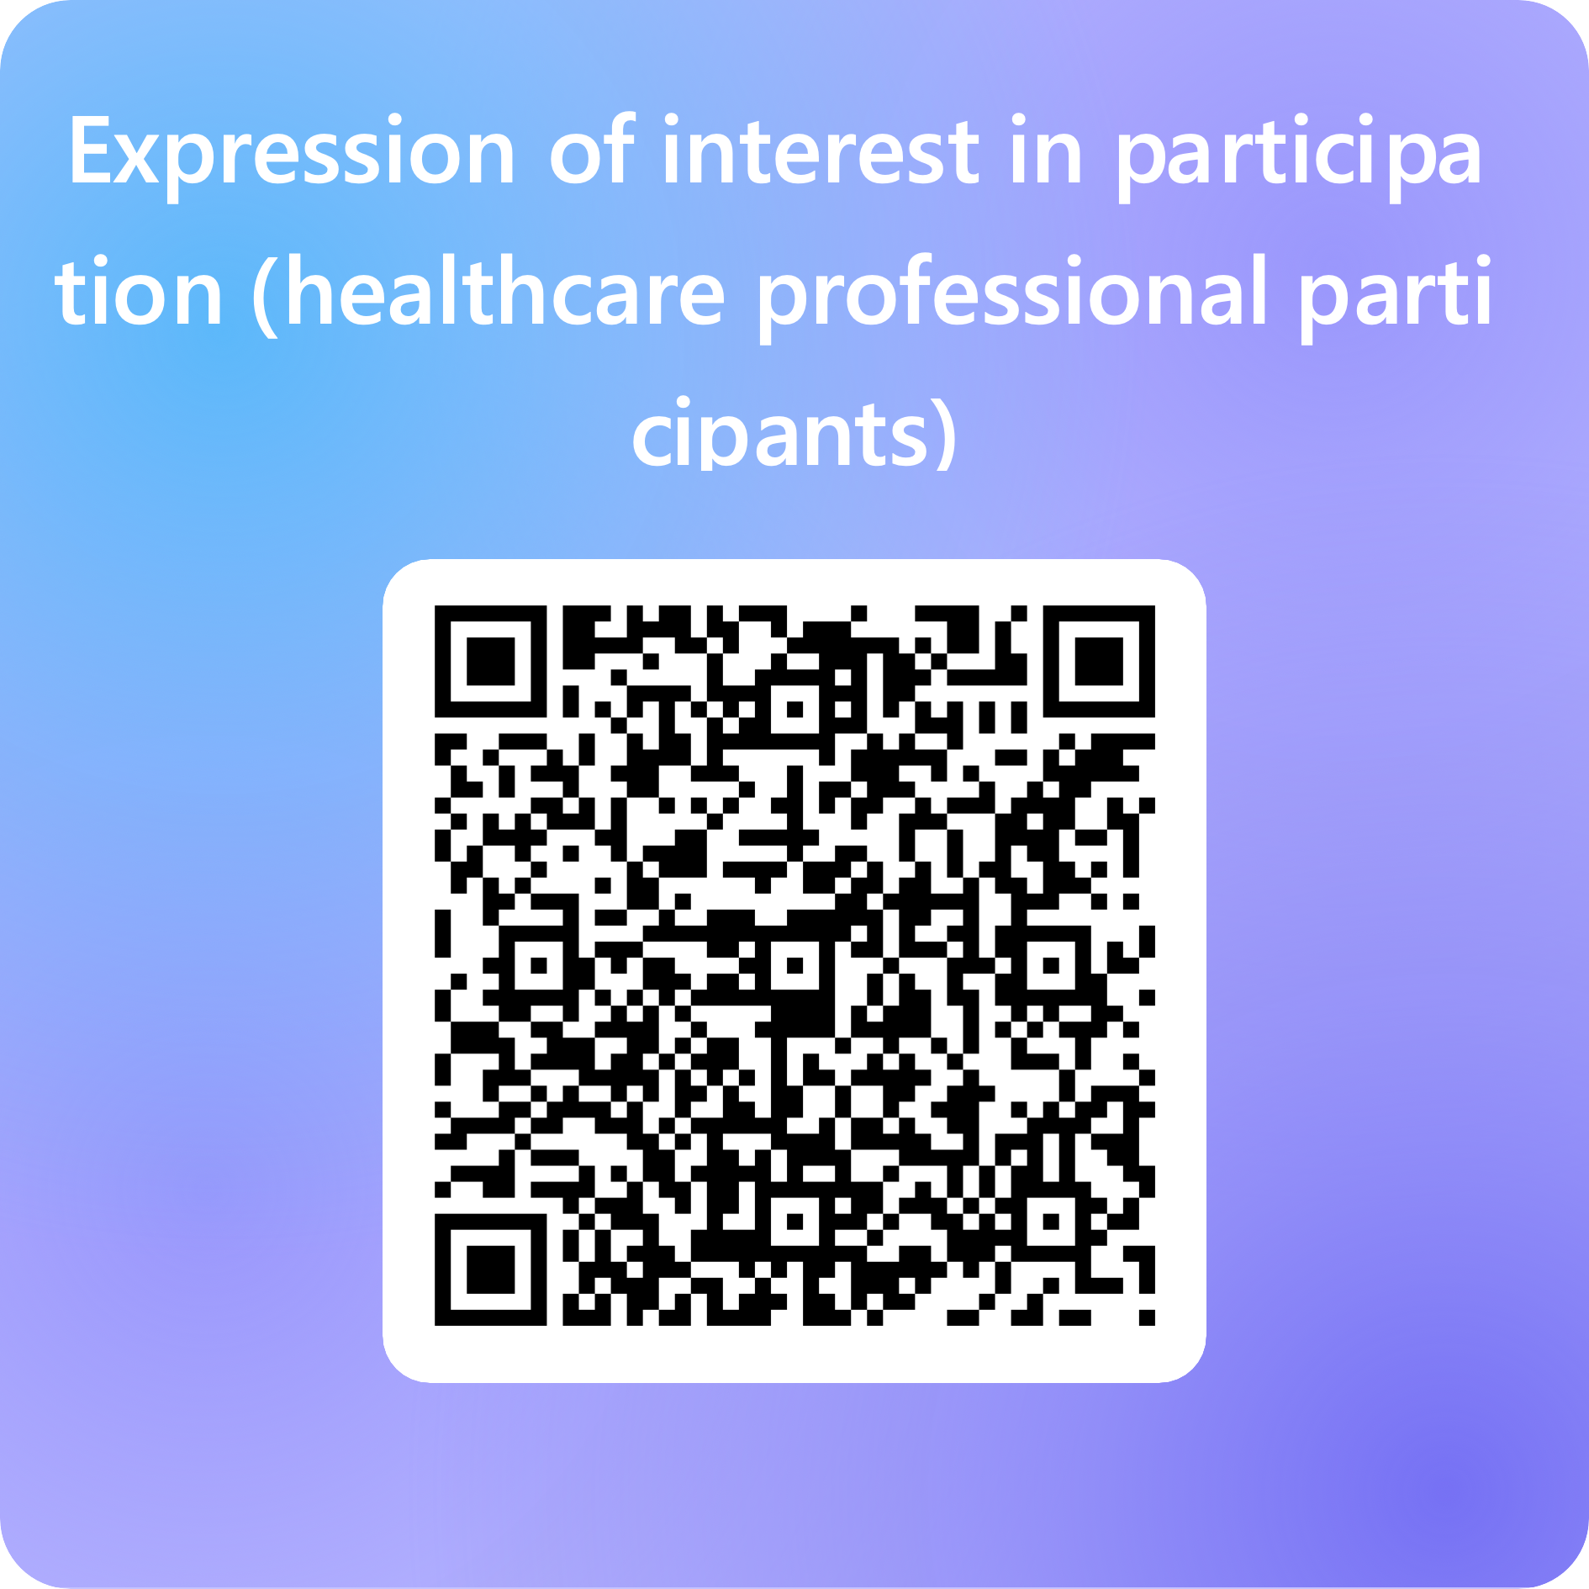

Expression of interest in participation (healthcare professional participants) – Fill in form

OR https://forms.cloud.microsoft/e/tRcgvQ3nvk

