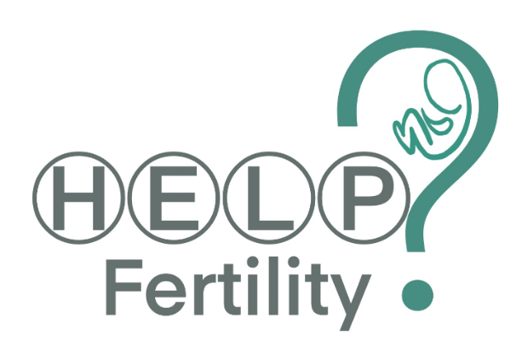

HELP? Fertility Trial
Who can take part?
Women experiencing infertility or recurrent miscarriage who have a confirmed diagnosis of endometrial polyps or submucous fibroids.
Summary
Submucosal fibroids are common benign growths in the muscle of the womb (uterus) and endometrial polyps are benign growths in the lining of the womb. Both are commonly found in women seeking treatment for fertility and recurrent pregnancy loss.
If you have small fibroids or polyps (less than 3cm) then one option is to have them removed in hospital by a surgical procedure called ‘hysteroscopic resection’. Another option is to leave them alone. Currently, we do not know whether removing or leaving small fibroids or polyps is going to improve your chances of having a baby.
This trial has been designed to establish whether removing or leaving small submucosal fibroids or endometrial polyps in place has the best effect on the chances of having a baby, for women who are seeking treatment for fertility or recurrent pregnancy loss.
Additional information
Please follow the link for an explanation of the trial
https://www.youtube.com/watch?v=Xykmge6rtxk&t=7s
This study has been ethically approved by the West Midlands - Edgbaston Research Ethics Committee, REC number: 21/WM/0013
If you are interested in taking part, please contact Ginny.Mounce@wrh.ox.ac.uk

