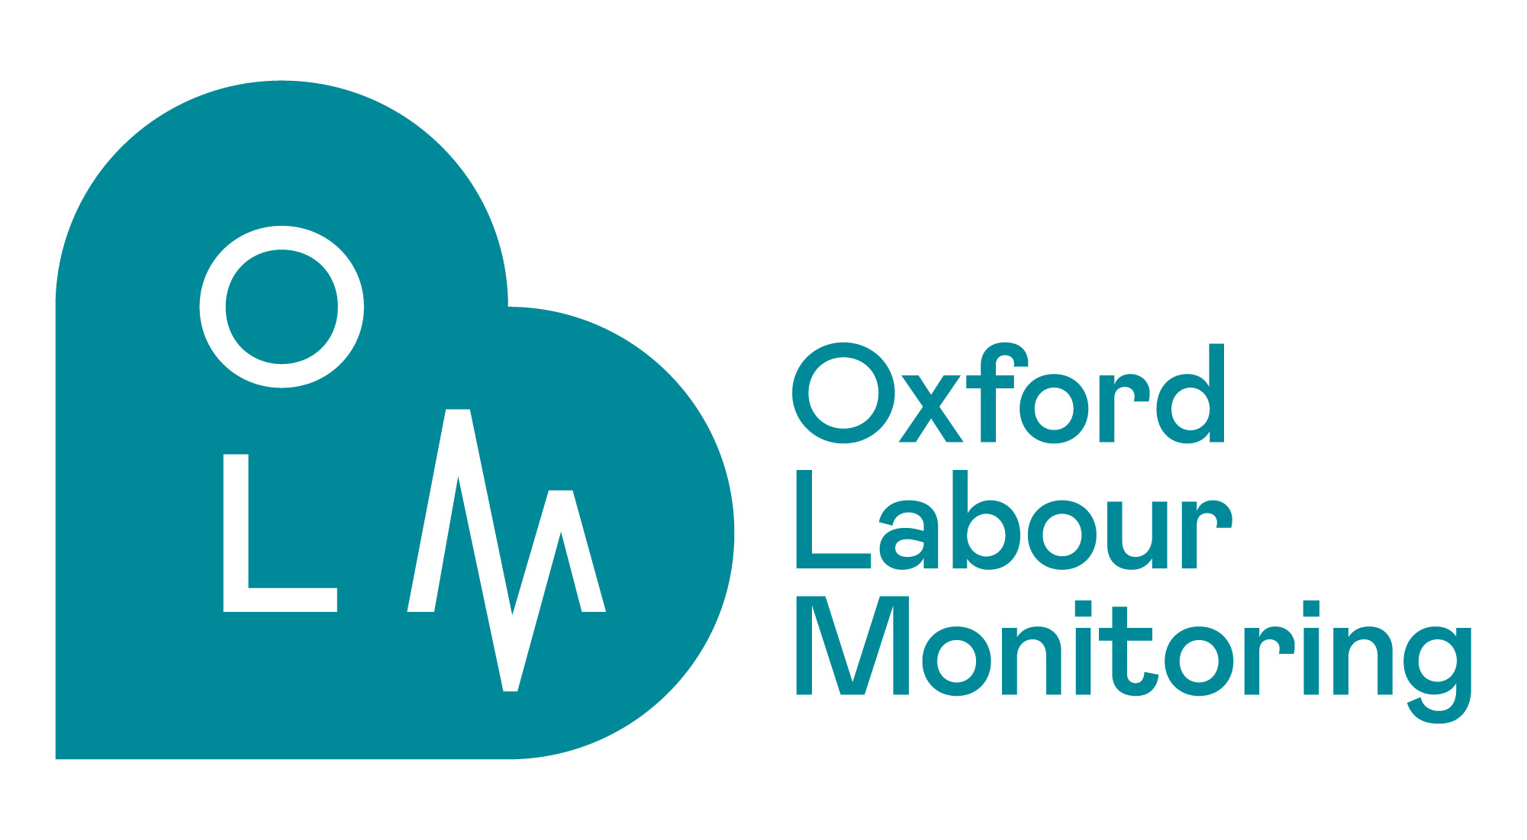

“Deep Learning Models for Fetal Monitoring and Decision Support in Labour”
(A three year EPSRC project (£762K) - collaboration of University of Portsmouth and University of Oxford)

Workshop “Rising Public Engagement and Awareness of the Project”
University of Portsmouth, Future Technology Centre, PO1 3AH, Tuesday, 13th June 2023, 12:30 - 17:30

Time | Topic
12:30-12:40 | Welcome & Introductions (Ivan Jordanov)
12:40-13:00 | Light Lunch
13:00-13:20 | Project Development Current Progress (Ivan Jordanov & Antoniya Georgieva)
13:20-13:45 | Parent, Patient and Public Involvement (Charlotte Bevan & Rachel Plachcinski)
13:45-14:15 | Data-driven Fetal Monitoring at Oxford (Antoniya Georgieva)
14:15-14:45 | Deep Learning Models for Fetal Monitoring and Risk Assessment (Daniel Asfaw)
14:45-15:00 | Tea/Coffee Break
15:00-15:30 | Fetal Monitoring Midwives’ Perspective (Catherine Hopley & Sarah Blackwell)
15:30-15:45 | Role of social determinants of health on AI-driven CTG intrapartum decision-support tools (Veronica Gutierrez, midwife PhD student)
15:45-16:20 | Discussion and Next Stages (All)
16:20-16:30 | Closing Remarks (Ivan Jordanov & Antoniya Georgieva)
16:30-17:30 | Spinnaker Tower Visit
Programme

